Fabien Bièvre-Perrin

(Gerda Henkel Stiftung/Aix-Marseille Université - LabexMed, USR 3155 IRAA)

The different faces of the Lernaean Hydra in contemporary pop culture: from cinema to video games, in: thersites ## (20##), x-x.

Keywords

Videogames, Cinema, Hydra, Herakles, Pop culture

Abstract

The Lernaean Hydra is one of the most famous ancient monsters. As the opponent in second of the labours of Herakles, it has known a great success through reception since Antiquity. Through the centuries, the monster has known many evolutions: for example, it has grown horns and legs, sometimes it even breathes fire! In this article, we will see how this mythological figure manifests itself in recent pop culture, especially in the movies and video games, as well as why and how it has evolved.

As one of the main monsters of one of the most taught and representend greek myths, the labours of Herakles, the Lernaean Hydra has known a great success through reception since Antiquity. This multi-headed monster is at the origin of a great variety of citations, mostly in politics and literature to start with, then in all kinds of productions, from cinema to games, amusement parks or comics. In this article, we will see how this mythological figure manifests itself in recent popular culture, especially through movies and video games.
- The original Hydra
In greek and roman myths, the Hydra (“water snake”) is a serpentine water monster, which lair is the lake of Lerna, in Argolid, an entry to the Underworld. Its parents are Typhon and Echidna, two noxious creatures, who bequeathed to their offspring their serpentine nature. The Hydra possessed many heads, the number differs from one source to another. Soon, the storytellers made the monster evolve, enabeling it to regrow twice as many heads lost.
Herakles is confronted to this creature during the second of his Labors. To kill it, he asks his cousin Iolaos for help. Together they cut off all of the heads and burn the wounds in order to prevent the heads from growing back. In some versions, Herakles cuted off the one immortal head with a sword given to him by Athena and placed it under a rock. He then dipped his arrows in the monster’s poisonous blood.
In Antiquity, the Hydra is mostly depicted as an opponent to Herakles, in a position of attack or defence (Fig. 1). It is usually the fight itself that is represented, even if most of the time, the hero is already shown winning over the monster. His arm is raised, a weapon in his hand, ready to strike a fatal blow. In both Greek vases and Roman mosaics, the hydra is either represented as a kind of snake-knot with several heads, but only one tail, or as a multi-headed snake with a big tail. In Roman peiod, Iolaos as a tendency to disappear. The number of heads varies a lot, there seems to be no rule, but they often bear a crest with an unclear origin. Its size varies, but it occupies a place equivalent to that of the hero. The artists try, each in their own way, to give the idea of a body entirely covered with scales, necessarily widened given the scales of representation. It seems like bronze sculpture of the monster were more naturalistic: the Herculanum one is a snake of reasonable size, like a python, wrapped around a trunk, whose five heads move around aggressively. In some representation, we can see the large crab Hera sent to distract him, hoping for his death, which the hero crushed with his foot.
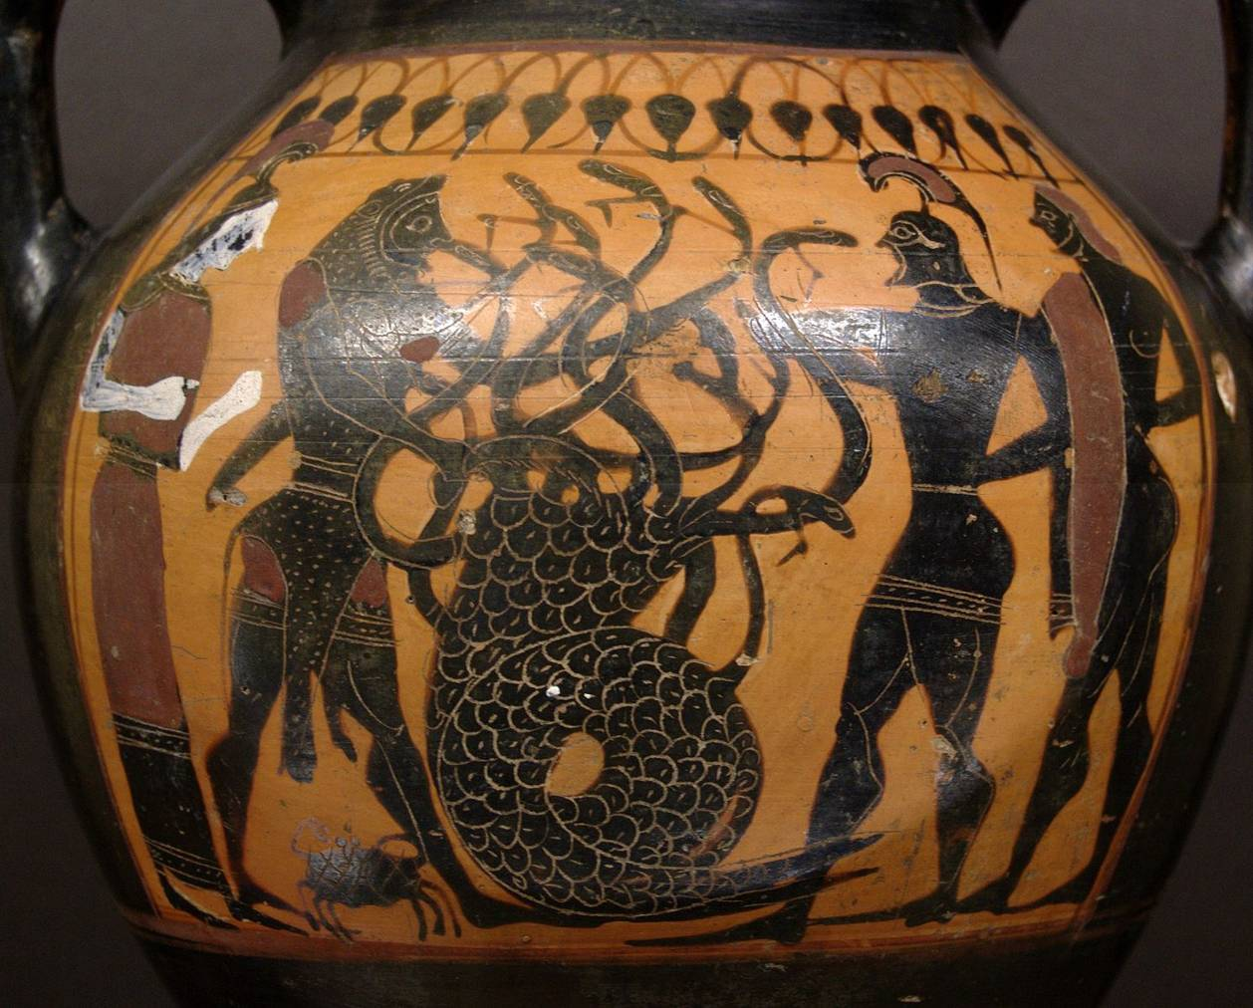
Fig. 1. Heracles and Iolaos fighting the Lernaean Hydra. Black figure amphora. Manner of the Princeton Painter (circa 540-530 BC). Musée du Louvre, Atlas database: entry 5795. Public Domain.
- The contemporary Hydra
The multi-headed monster that currently haunts the marshes and attacks Heracles and other related heroes has little to do with the original mythological monster. First of all, it migrated to various countries and environments, sometimes far from water, and grew a lot, generally becoming a giant, it acquired legs and dragon-ears/horns appeared to crown its head(s), in some cases, it even breaths fire. This legged-hydra has proliferated in the visual arts, gradually becoming dominant (in biology it’s called an intraguild predator), without ever totally eradicating his ancestor. It seems less furtive and agile, it has become unbalanced, as its change in size implies: scarcely larger than a big serpent in antiquity, it became a more and more gigantic creature, able to constitute an impressive and brutal "endboss" in videogames and movies. How do we go from a snake with many heads in Antiquity to such a chimerical monster today?
The following table summarizes some of the characteristics of the Hydras in some outstanding movies (peplums, superhero and fantasy films) and video games. Other instances can be found, and many more in other kind of productions, like comics and tabletop role-playing game for example.
Movies and tv shows | Date | Head(s) | Legs | Breathing fire | Giant
Gli amori di Ercole (Carlo Ludovico Bragaglia) | 1960 | Dragon | X |  | X
Jason and the Argonauts (Don Chaffey) | 1963 | Dragon |  |  | X
Hercules: The Legendary Journey | 1994 | Dragon | X | X | X
Hercules (Disney) | 1997 | Dragon | X |  | X
Hydra (Andrew Prendergast) | 2009 | Worm ? |  |  | X
Percy Jackson and the Olympians: The Lightning Thief (Chris Columbus) | 2010 | Dragon | X | X | X
Marvel movies | Since 2010 | Octopus
Hercules (Brett Ratner) | 2014 | Dragon |  |  | X
Videogames | Date | Head(s) | Legs | Breathing fire | Giant
Heroes of might and magic | Since 1986 | Varies | Varies |  | X
Final Fantasy | Since 1987 | Varies | Varies | Varies
Age of Mythology | 2002 | Dinosaur | X |  | X
Titan’s quest | 2006 | Dragon | X | X | X
Pokémon (Hydreigon) | Since 2010 | Dragon | X |  | X
Warriors Orochi 3 | 2011 | Dragon |  | X | X
Dragon’s dogma | 2012 | Serpent |  |  | X
Kid Icarus Uprising | 2012 | Dragon |  |  | X
World of Warcraft | Since 2014 | Dragon | X |  | X
Atlas | 2018 | Dragon | X | X | X
- The laws of evolution
The first evolution of the Hydra is seen at the end of the medieval age. Indeed, it seems that graeco-roman representations of the monster collided with representations of dragons and biblical monsters, in particular the seven-headed dragon of the Apocalypse. Like the Hydra, this beast has regeneration ability (a mortal wound which healed itsef), more than one head and comes from the water, as it emerges from the sea. But the dragon of the Apocalypse looks like a leopard, has the feet of a bear and the mouth of a lion. Then, after a long absence, the Hydra is massively back in the XVIth century with new features: various heads, two or four feets (sometimes webbed, like an amphibian), breath of fire... Herakles often looks like Saint Michel or Saint Georges slaying the dragon. During the Renaissance, the rediscovery of ancient depiction seems to give back a place to more traditional representations, but the influence of other monsters like the Chimera or ancient statues like the Laocoon accelerate the iconographic diversification of the Hydra (Fig. 2). Later, the important archaeological discoveries, in Pompeii and Herculaneum in particular, inspire artists a return to the old models. We can think of Gustave Moreau’s Héraclès et l'hydre de Lerne (1876, Fig. 3) or Rudolf Tegner’s Herakles and the Hydra (beginning of the XXth century). Iolaos is rarely figured helping Herakles.
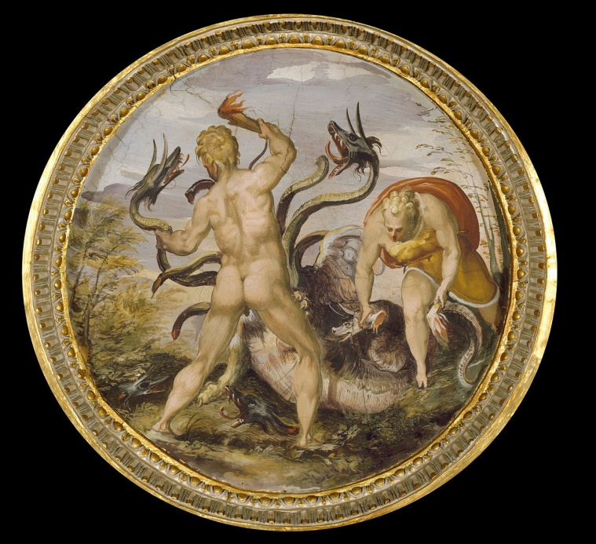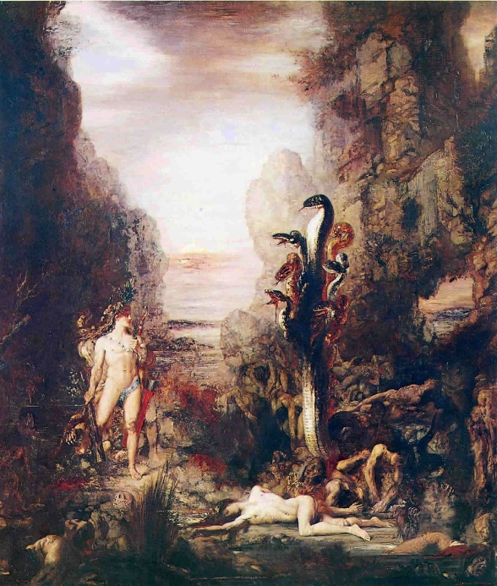
Fig. 2. Marco Marchetti from Faenza (1555 - 1556)- Herakles and the hydra from Lerna. Oil Painting on wood. Palazzo Vecchio Museum. Public Domain.
Fig. 3. Hercules and the Hydra Lernaean by Gustave Moreau (1876). Oil on canvas. Art Institute of Chicago, 1964.231. Public Domain.
Those last models seem to have inspired the serpentine Colchis dragon Ray Harryhausen conceived for Jason and the argonauts in 1963 (Fig. 4). His version of the monster could be seen as an animated evocation of the ancient paintings and their modern revivals, with a touch of medievalism for the heads and the colour. Except for the very kitsch Gli amori di Ercole (Carlo Ludovico Bragaglia) in 1960, no peplum had put on film the multi-headed monster yet: Herakles and Maciste were confronted to lions, crocodiles, even dinosaurs or vampires, but no Hydra. With the Harryhausen model, the hydra becomes a pop icon, even without the presence of Herakles. Its influence is sensible in various peplums, cartoons, televisions series, like Hercules: The Legendary Journeys (1995-1999).
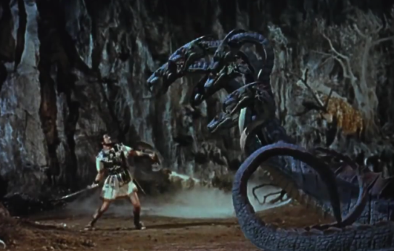
Fig. 4. Jason and the Argonauts, trailer for the film (Columbia Pictures, 1963). Public Domain.
With the innovations in video-games and the transition to 3D during the nineties, as well as with the regain of popularity of peplums in the 2000’s, creators made the Hydra a classic opponent in their scenarios and adapted it to their needs. Despite the influence of Harrihausen, the legged Hydra becomes the main form of the monster. Is this a simple escalation in “monster design”, an attempt to create a new version to avoid accusations of plagiarism, to renew the range of ancient monsters, or to take advantage of the possibilities offered by the new technologies?
Given the success of medieval fantasy and dragon movies (Lord of the rings, Eragon, Reign of Fire, Dungeons & Dragons) at the beginning of the 21st century are responsible, it is likely that after developing digital models and technologies to animate dragons in movies and video-games, they were reused for the Hydra when needed. Concerning video games, it is also possible that the adjunctions of legs to the monster made it easier to animate, the movements of a snake being difficult to render then. The fact that in 1997, the Hydra in the Disney movie was the only character completely done in CGI (Computer-generated imagery) is noticeable, especially given that a video game accompanied the film's release.
Beside their monstrosity, the success of hydra-like monsters is clearly linked to their ability to regenerate. It’s one of the main “characteristics” listed for hydras in videogames and a graphic challenge opportunity in movies (but in some cases, the heads don’t grow back, as in Kid Icarus Uprising, 2012). What is interesting here, is that often, knowing the name of the creature or recognizing it from its appearance, the gamer knows already that the heads will grow back, unlike the movie heroes. Indeed, in the Disney movie or in the first Percy Jackson, the young heroes make the mistake of cutting off the heads of the chain, creating a gigantic monster. The Hydra is also probably popular because of its closeness to medieval dragons. It allows a diversity in monsters and give an ancient and aquatic counterpart to their flying cousins. This characteristic is important in movies, as the monster can hide in plain sight, rising from the waters by surprise, as we can witness it in the Brett Ratner movie (Hercules 2014).
The Hydra also appears more subtly in popular culture. Indeed, the term is often used to refer to sprawling, secret and dangerous organisations. The best example would be the terrorist organisation Hydra in the Marvel Universe. Its motto is a statement of resilience and growing strength: “If a head is cut off, two more shall take its place”. The logo, however, evokes more an octopus than a hydra. Probably because the octopus and the Hydra have been used in propaganda and politics for the same reasons: to embody corruption, or a sly and erratic political enemy (Fig. 5 ; Fig. 6 ; Fig. 7).
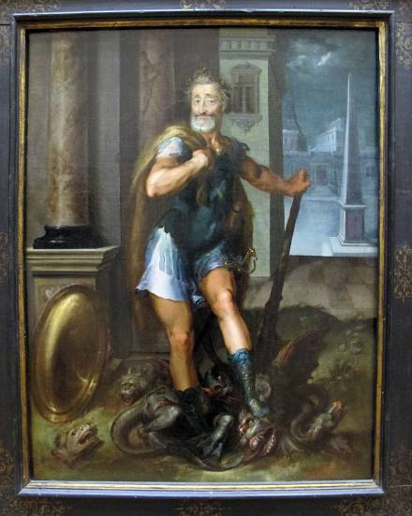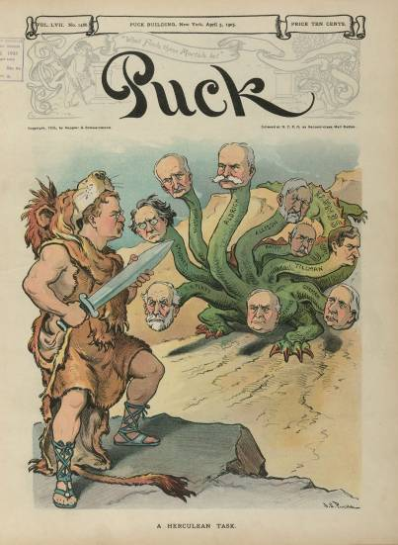
Fig. 5. Toussaint Dubreuil (?): Portrait of Henry IV as Hercules Slaying the Lernaean Hydra (circa 1600). Musée du Louvre, Atlas database: entry 1110. In this painting, the Hydra is associated to unsubdued Catholics – Maréchalle (2018).
Fig. 6. « Confiance – ses amputations se poursuivent méthodiquement » [Have Faith - its systematic amputations are continuing], by S.P.K., 1942. CC BY-NC-SA 3.0 : Cornell University – PJ Mode Collection of Persuasive Cartography. Online : https://digital.library.cornell.edu/catalog/ss:19343465
Fig. 7. Theodore Roosevelt as Hercules battling a nine-headed hydra (each head is identified as a senator, the tail as the U.S. Senate). John S. Pughe, 1905. Prints and Photographs division. Library of Congress Prints and Photographs Division. https://www.theodorerooseveltcenter.org/Research/Digital-Library/Record?libID=o278090. Theodore Roosevelt Digital Library. Dickinson State University.
- Conclusion
The Lernaean Hydra is a key figure in classical themed movies and videogames. Its abilities and acquaintance with other popular monsters (dragons, Kraken, Chimera) made it a perfect opponent for heroes and gamers (who is often alone, as Iolaos disappeared from representations). Unlike other monsters that can be the subject of some sympathy, Medusa can be seen as a victim for example, the Hydra is always an incarnation of evil, probably because of the legacy of the beast of the Apocalypse. Its symbolics and political uses are also important in its contemporary reception, as hydras are seen as malicious, vicious and unpredictable creatures.
It’s the classical context or the onomastics that convey the Hydra its identity. Multi-headed monsters in non classical themed movies and video-games are rarely hydras, they’re less maleficent, often anomalies of Nature or the result of failed scientific experiments. The gamer or the spectator identifies the Hydra, its Antiquity and its particularities, and associate it to a particular imaginary: the monster is out of our world, an absolute evil force, like an illness, neither a curiosity of nature, nor a human error. In all, the Hydra gives substance to what every hero must oppose, and therefore gives the possibility of overcoming it.
Bibliography
Amandry (1944). – Pierre Amandry, ‘Skyphos corinthien du Musée du Louvre’, Monuments et mémoires de la Fondation Eugène Piot 40 (1944) 23–52.
Benoit (2008). – Monique Benoit, ‘Ilana Löwy L’emprise du genre. Masculinité, féminité, égalité. Paris, Éditions La Dispute, 2006, 277 p. [book recension]’, Recherches féministes 21, 1 (2008) 189–193.
Besnard (2017). – Tiphaine-Annabelle Besnard, ‘L’Athéna Parthénos américanisée : de la sculpture d’Alan LeQuire au décor du film Percy Jackson, le Voleur de foudre’, in: Fabien Bièvre-Perrin (ed.), Antiquipop (Lyon 2017). Online: https://antiquipop.hypotheses.org/2559.
Cixous (1976). – Hélène Cixous, ‘The Laugh of the Medusa’, Signs 1, 4 (1976, translation 1975) 875–893.
Delon (2014). – Gaspard Delon, ‘Avatars du péplum ? Présences de l’Antiquité gréco-latine dans les genres cinématographiques du fantastique, de la fantasy et de la science-fiction’, in: Mélanie Bost-Fievet & Sandra Provini (ed.), L’Antiquité dans l’imaginaire contemporain. Fantasy, science-fiction, fantastique (Paris 2014) 65–79.
Dumont (2009). – Hervé Dumont, L’Antiquité au cinéma. Vérités, légendes et manipulations (Paris-Lausanne 2009).
Clasen (2012). – Mathias Clasen, ‘Monsters Evolve: A Biocultural Approach to Horror Stories’, Review of General Psychology 16, 2 (2012) 222–229.
Cuvelier (2018). – Pierre Cuvelier, ‘Le Choc des titans et ses répliques : diffusion et réappropriation ludique de nouveaux types figurés mythologiques dans les arts visuels’, in: Fabien Bièvre-Perrin & Élise Pampanay, (ed.), Antiquipop : La référence à l’Antiquité dans la culture populaire contemporaine (Lyon 2018). Online: https://books.openedition.org/momeditions/3383
Jung (1966). – Marc-René Jung, Hercule dans la littérature française du XVIè siècle : De l'Hercule courtois à l'Hercule baroque (Genève 1966).
El Kenz (1992). – David El Kenz, ‘Le roi de France et le monstre dans les gravures : genèse et déclin politique d'une image aux XVIe et XVIIe siècles’, Matériaux pour l'histoire de notre temps 28 (1992) 3-7.
Gaignebet (1975). – Jean-Baptiste Gaignebet, ‘Essai sur le cheminement d'Hercule au cours de l'Histoire de France’, Provence historique 99 (1975) 111–124.
Harryhausen et Dalton (2008). – Ray Harryhausen & Tony Dalton, A Century of Model Animation. From Méliès to Aardman (New York 2008).
Hougron (2005). – Alexandre Hougron, ‘La figure du monstre dans la littérature et au cinéma : monstre et intertextualité’, La page des Lettres (2005). Online: https://lettres.ac-versailles.fr/spip.php?article28#s-References
Kerenyi (1959). – Karl Kerenyi, Asklepios, archetypal image of the physician's existence (New York 1959).
Kokkorou-Alevras (1990). – Georgia Kokkorou-Alevras, ‘C. Herakles and the Lernaean Hydra (Labour III) ’, in: LIMC V, 1 (Bern 1990) 34–43.
Maréchalle (2018). – Stéphane Maréchalle, ‘Portrait d’Henri IV en Hercule terrassant l’hydre de Lerne’, Petite galerie ! (Paris 2018). Online: https://petitegalerie.louvre.fr/oeuvre/portrait-d%E2%80%99henri-iv-en-hercule-terrassant-l%E2%80%99hydre-de-lerne
Mailley-Von Arx (1982). – Marie-Christine Mailley-Von Arx, ‘Art grec archaïque et rapport sociaux : pour une approche du fonctionnement de l'icône dans la société grecque archaïque’, Dialogues d'histoire ancienne 8 (1982) 283–302.
Murphyao (2015). – Amanda Murphyao, ‘The Many-Headed Hydra: Monstrous Representations of Canadian Confederation and the American Civil War in Cartoons, 1861-1867, This dissertation is going to be fun, like dessert (Ottawa 2015). Online: https://dessertating.wordpress.com/2015/04/16/hydra/
Ogden (2013). – Daniel Ogden, Drakon: Dragon Myth and Serpent Cult in the Greek and Roman Worlds (Oxford 2013).
Shapiro (1990). – Harvey Alan Shapiro, ‘Old and New Heroes: Narrative, Composition, and Subject in Attic Black-Figure’, Classical Antiquity 9, 1 (1990) 114–148.
Ulrich (2010). – Stefan Ulrich, ‘In der Hydra-Republik’, Süddeutsche Zeitung (14/10/2010). Online: https://www.sueddeutsche.de/politik/skandale-in-frankreich-in-der-hydra-republik-1.999892
Venit (1989). – Marjorie Susan Venit, ‘Herakles and the Hydra in Athens in the First Half of the Sixth Century B. C.’, Hesperia: The Journal of the American School of Classical Studies at Athens, 58, 1 (1989) 99–113.
Wolff (2018). – Nadège Wolff, ‘« Kid Icarus » : un héros antique qui peine à prendre son envol ? Du rétrogaming au retour en fanfare dans les années 2000-2010’, in: Fabien Bièvre-Perrin (ed.), Antiquipop (Lyon 2018). Online: https://antiquipop.hypotheses.org/3833.
Zavadski (2014). – Katie Zavadski, ‘Putin’s Birthday Present Is a Hercules-Themed Art Show About How Manly and Amazing He Is’, Intelligencer (6/10/2014). Online: http://nymag.com/intelligencer/2014/10/putin-birthday-present-hercules-art-show.html

“Hydra the Revenge” Pennsylvania, United States : https://en.wikipedia.org/wiki/Hydra_the_Revenge
The first mention of the Labour is in Hesiod Theogony [310-318]. For a list of literary source and a short bibliography, see Kokkorou-Alevras (1990) 34-35 ; Ogden (2013) 26–30.
Kerenyi (1959) 144.
The first occurrence in greek pottery dates from 570-550 BC. The scene is one of the most popular labours in Antiquity, especially in Corinth – Shapiro (1990) 123. “The representations of the Labour illustrate eclectically all the literary evidence about the task” – Kokkorou-Alewras (1990) 43.
See for example Amandry (1944). It might also be represented as a victim alone – Kokkorou-Alewras (1990) 41.
And in the Roman period, the Hydra might be represented with a female bust/head – Kokkorou-Alewras (1990) 42–43.
Ogden (2013) 161.The Dolchian Dragon has a crest (Ovid, Metamorphoses 7. 149 ff).
Most of the time, but in some cases it may be a little bigger, see for example the pediment of the Acropolis – Mailley-von Arx (1982) 294, Venit (1989), Kokkorou-Alewras (1990) n. 2021.
Herakles did kill another multi-headed snake, Ladon, in the Garden of the Hesperides. It is possible that some representation associated to the Hydra are in fact Ladon.
Ogden (2013) 28.
On the relationship between peplum and other films, including fantasy films, see Delon (2014).
In peplums, Hervé Dumont lists only two occurrences before 2009, so my list must be almost exhaustive – Dumon (2009) 164, 168.
Revelation 11:7 ; 13:1-10 ; 17:7-18. Originally, the Hydra is not a greek drakōn but a water snake – Ogden (2013) 28, 383 (Chap. 11: “The Birth of the Christian dragon”).
The XVIth century represents a kind of golden age for Herakles in France – Jung (1966) –, after a period of disinterest when physical strength is no longer glorified – Gaignebet (1975) 116–117.
Harryhausen & Dalton (2008).
In this movie, the monster is more of a three headed (like Cerberus) dragon than an Hydra: it looks like a vulgar fair attraction, its head don’t grow back.
The same happened to Medusa, as the one conceived by Ray Harryhausen for Clash of the Titans (Warner Bros, 1981) became an almost unique reference for later representations of the monster – Cuvelier (2018).
“Hercules and the Amazon Women”, Hercules: The Legendary Journey, S1E1, 1994.
There is even a dragon called Hydra in the role-playing game Dungeons & Dragons (Gary Gygax & Dave Arneson, booklet "Monsters & Treasure", in Dungeons & Dragons boxed set, 1974, 10).
Kid Icarus Uprising (2012) stands out again since its hydra, devoid of legs or wings, flies – Wolff (2018).
See for example Ulrich (2010) and Zavadski (2014).
Even ancient representations are sometimes unclear, the numerous octopus present in the Mediterranean may have inspire painters. Describing a corinthian skyphos with the Hydra, Pierre Amandry talks about tentacles – Amandry (1944) 26.
Murphyao (2015) ; El Kenz (1992). The monster can also embodies patriarchy for example: Ilana Löwy stages the power of the myth of gender equality through an allegory of the Hydra – Benoit (2008).
See Cixous (1976) and its legacy in recent pop culture. Even Cerberus can be represented sympathetically (Harry Potter and the Philosopher's Stone, 2001).
Even in Percy Jackson, the hydra is staged in an “ancient” location, the Nashville’s Parthenon – Besnard (2017).
The thriller Hydra directed by Andrew Prendergast in 2009 is a particular case as the movie has nothing to do with classics, except that the monster, awoken by an archaeologist, was sleeping since Antiquity.
It is the perfect horror monster as Mathias Clasen puts it in his article “Monsters Evolve: A Biocultural Approach to Horror Stories” – Clasen (2012) 224, 227.
Hydra can be an allegory of cancer.
It can also be seen as primordial – Hougron (2005).

